SEND PROFORMA AND INVOICES EMAIL FROM ODOO

STEP 1 (optional):

* Go to partner form to check partner/client email addresses

* Email will be sent on partner's primary email or secondary email or both

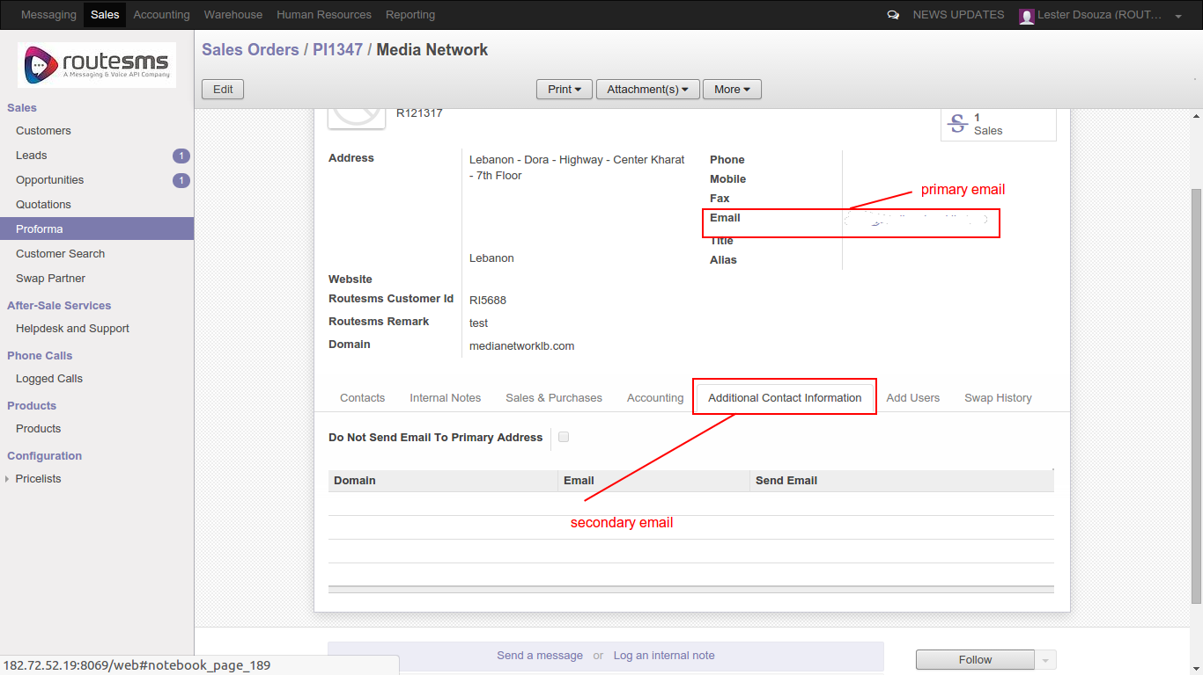

STEP 2(proforma):

* Go to sale-> quotation or proforma -> open record-> click “send by email” button

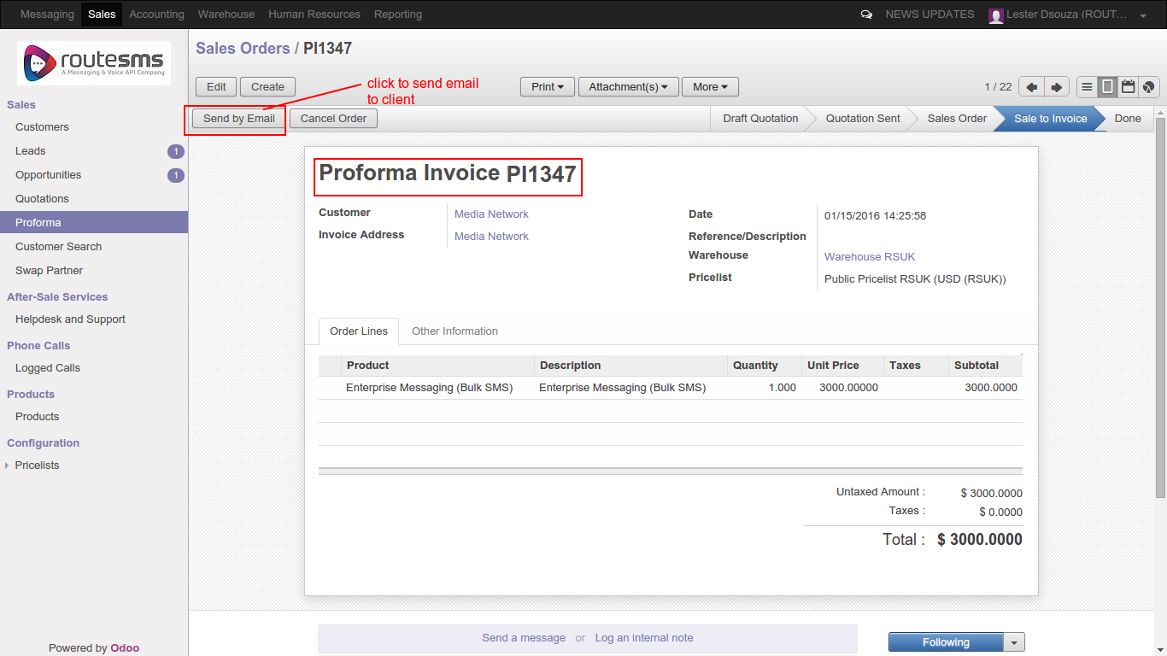

STEP 3:

* Click “send” button to send proforma email to partner/client

* BCC / carbon copy of email with attachment will be send automatically on salesperson's email address.

* Email address of partner and salesperson will be picked from backend automatically

* Proforma attachment will be picked automatically from backend

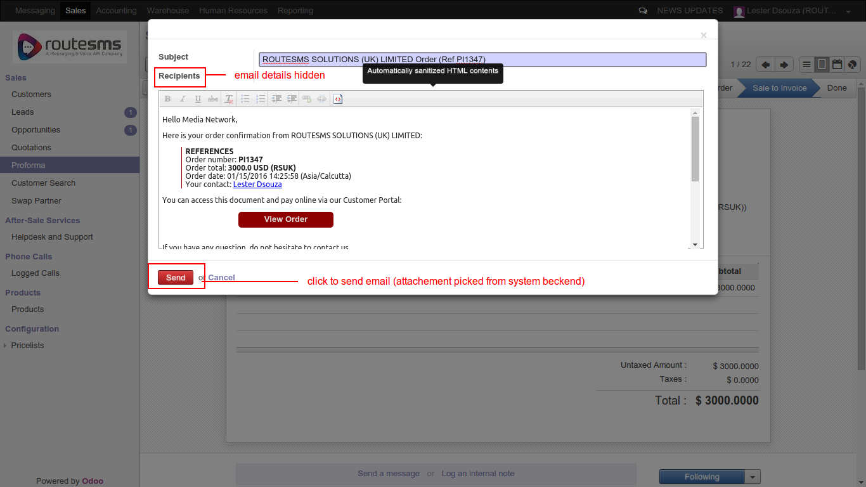

STEP 4(sales invoice) :

* Go to accounting-> customer invoice -> open record-> click “send by email” button

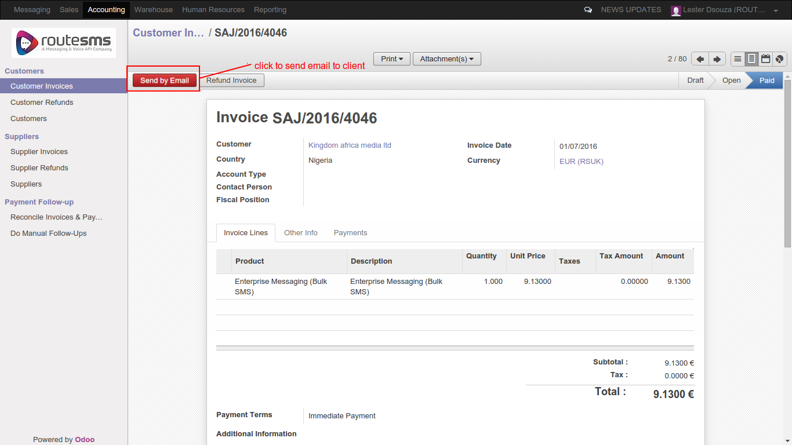

STEP 5:

* Click “send” button to send customer invoice email to partner/client

* BCC / carbon copy of email with attachment will be send automatically on salesperson's(routesms) email address and accountant's(routesms) email address .

* Email address of partner ,salesperson(routesms) and accountant(routesms) will be picked from backend automatically

* Sale invoice attachment will be picked automatically from backend

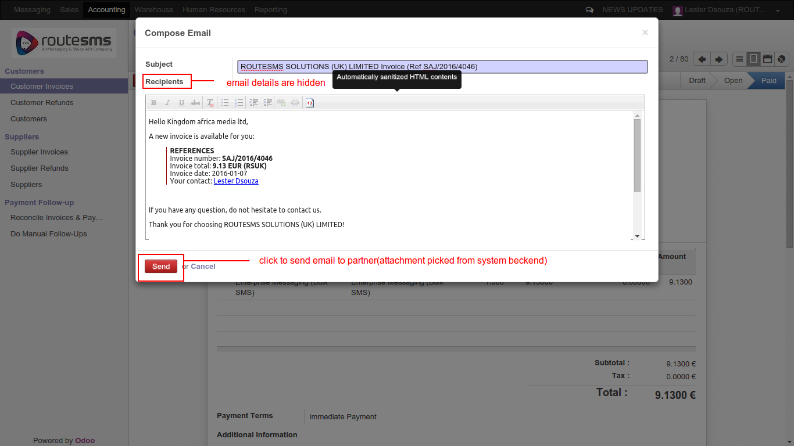

THANK YOU

For any query kindly contact:

skype: bista_shashank
email: shashank.verma@bistacloud.com
ext: 684

